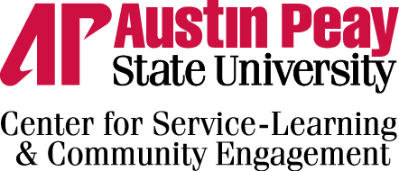
Service – Learning Risk Management Plan
The purpose of the Service – learning risk management plan is insure the proper consideration for student safety and liability have been put into place for service – learning course participation. Service – learning at Austin Peay State University encourages the use of student experience with non – profit organizations as a learning strategy. By nature of the experience, students may come into contact with a higher risk of liability through these experiences. The plan outlines the steps taken by the center for service – learning and community engagement to educate the student on risk and clarify the roles and responsibilities of the community partners and faculty.
- Use of the Student Service – Learning Acknowledgement document
The purpose of this document is to educate the student on potential risks, safety & well-being, transportation, financial responsibility, and personal conduct. This document is to be signed by the student at the beginning of the semester before they partake in any activity related to service – learning outside of the classroom. This document is be retained by the faculty member with copies housed in the center for service – learning & community engagement.

- MOU Community Partnership Agreement
The purpose of this document is to outline the roles and responsibilities of the student, community partner, and faculty member during the course of the service – learning experience. This document must be signed at the beginning of the semester before activity related to service – learning outside of the classroom begins. This document is to be signed by a representative of the community partner and the vice president for student affairs. This document is to be retained by the center for service- learning and community engagement and is a binding agreement.

- Student orientation/ training on site
These guidelines are provided for community partners to outline the topics to be covered upon site orientation/ training when students first arrive at the community partner site. The coverage of these topics should lessen the risk for students and the community partner

- Site Visit Evaluation
In conjunction with the MOU community partnership agreement, a site visit evaluation will occur to sites where students will be physically present. These site visits will occur once every 5 years and will be conducted by the faculty member or the director for service – learning and community engagement.

The resulting documentation relating to the Risk Management plan contains:
- Student service – learning acknowledgement document
- MOU community partnership document
- Site orientation/ training checklist
- Site visit evaluation document

