Winter Term Look up Classes and Registration Information

Looking up Classes and Registering

Schedule of Classes – Winter Term link
  - Log in to OneStop and click on the Registration link under the Student Tab.
  - Click on Schedule of Classes – Winter Term
  - You will then be taken to the page Schedule of Classes and then click on the Show Schedule button. If you are looking for a specific department narrow the search by department otherwise select All Departments and all of the Winter Term courses will populate on the PDF. If you want to see only open sections, please click the box next to Show open sections only.
All Winter Term courses are online.

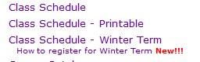
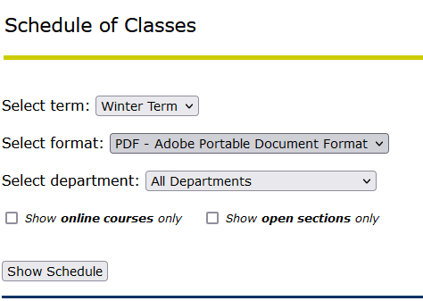

- This will display all course for the Winter Term in a PDF. Take the CRN and proceed to Add/Drop

NOTE: prior to the Add or Drop Classes page, you may be prompted to answer questions regarding your Financial Aid. Once you answer those questions, you will then be sent to the Add or Drop Classes page as previously mentioned

Using Add or Drop Classes link
- Log in to OneStop and click on the Registration link under the Student Tab
- Click on the Add or Drop Classes link and you will be taken to the Registration Term page to select a term; select Winter Term; click the Submit button.
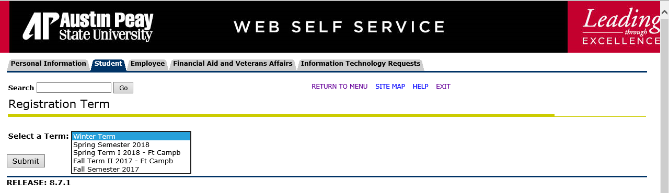

- You will then be taken to the Add or Drop Classes page.
- Enter the CRNs to for the Winter Term courses you wish to register for, which can be found by using the above Class Schedule – Winter Term on Web Self Service

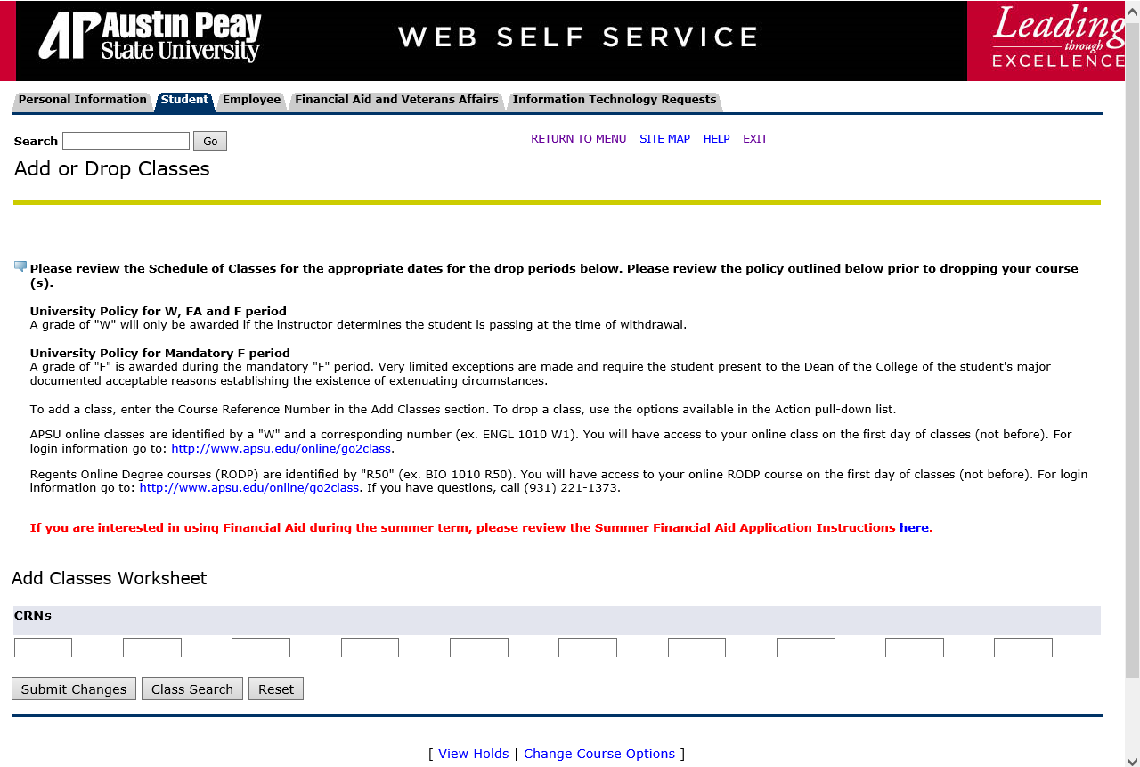

Select the courses you want to register for and then enter the CRN’s (found in Class Schedule) on the Add or Drop Classes page and Submit Changes.

NOTE: You may select up to 6 credit hours for Winter Term. No more than six
hours may be taken in Winter Term.

