Scholarship Reviewer Chairs

Signing in to the AcademicWorks Scholarship System
Selected faculty and staff will receive an e-mail invitation prior to the new year’s awarding cycle to begin reviewing scholarship applicants.

New Users
After clicking the invitation token, new users will be taken to an account setup screen where they will be required to set up a password.
Returning Users
Returning users will be directed to sign in to AcademicWorks using their previously set password.
All Users
Whenever signing in to AcademicWorks at https://apsu.academicworks.com/users/sign_in, be sure that the “References and Reviewers” tab is selected. Otherwise, you may sign in as an applicant. You will also need to sign in with your e-mail address, not your OneStop credentials.

Familiarizing Yourself with the System
The Reviewer Chair will see a list of scholarships to which they have been assigned reviews.
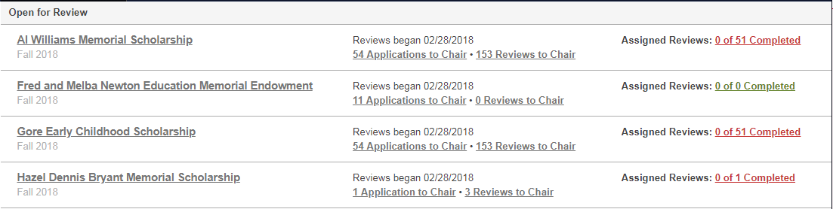

DETAILS |  | APPLICATIONS TO CHAIR | REVIEWERS TO CHAIR | ASSIGNED REVIEWS
Details You must view the description and available award amounts. Ensure selected recipients meet the donors’ criteria and offer award amounts that do not exceed the year’s spending figure.
- Financial Information --- Spending information for the year will be noted as “Total Remaining Amount”
- Opportunity-Specific Information ---- Review specific qualification criteria and whether prior recipients should be considered for renewal.
- Questions --- These are only listed if the scholarship has its own specific questions.

Applications to Chair Use to generate an Excel report with scholarship data for the applicants. Excel reports should be forwarded to other members of the committee.

For instructions on how to generate reports, see section titled Generating an Excel Report.

 | Reviews to Chair Use to view ratings made by the other members assigned to your Reviewer Group. This could be a lengthy listing, as an applicant will be listed one time for each reviewer in your group.
Reviews assigned to you Use to review individual applicant’s data and rate the students. For consistency we suggest a scale of 1-10 (with 10 being reserved for students of the highest quality).

Select the “Begin” button.
- Review tab -- Provides a rating field and area to describe any outstanding qualities of the student.
- Application tab – Use to review the student’s application to establish a rating.

Helpful feature:

“Side-by-Side” allows you to split the screen between the Review tab and the Application tab. To exit Side-by-Side view, click the link at the bottom.

For more information about being a Reviewer, read the complete set of Reviewer’s Instructions at: http://www.apsu.edu/scholarships/academic-scholarship-staff-resources.php

Generating an Excel Report:
While viewing Applications to Chair, “Scholarship View” should be displayed at the top. If not, hover over the View and select it. You can make Scholarship View the default by clicking the Star to the left. If “Scholarship View” is not an option, please inform Sherri Devers.

When you are confident you have selected the right View, you may download the report by clicking the Down Arrow button. The report will then be generated.

You will be notified when the report has been generated via AP email from Austin Peay State University Scholarships <APSUScholarships@apsu.edu>. The link in the email will direct you to log into the system to download your report.

Selecting Recipients and Notifying Financial Aid
Each department is free to design their own workflow for selecting recipients. However, we recommend the following procedure:

- Reviewers evaluate and rate all applicants.
- Reviewers share their top selections with the scholarship committee.
- The Reviewer Chair will have access to all Reviewers’ scores and comments.
- The scholarship committee determines the final selection(s).
- An authorized staff member fills out the scholarship recipient(s) using the Scholarship Award Submission Form located on the Staff Resources page at https://www.apsu.edu/scholarships/academic-scholarship-staff-resources
  - The Scholarship Award Submission Form is submitted to the Scholarship Coordinator in the Financial Aid Office. Early submissions benefit both the student and APSU by potentially increasing retention and recruitment.
  - Reminder:
    - Make evenly divided fall/spring disbursements
One-semester awards must be approved by Advancement Office
    - Select alternate recipients to ensure funds are spent and to avoid committees having to reconvene to make alternate selections
- We ask that departments do not send students notification of the scholarship, as official notification will come from the Office of Student Financial Aid

