SCHOOL NAME & LOGO

Counseling Center

SCHOOL ADDRESS
SCHOOL PHONE
SCHOOL FAX

Table of Contents
Guidance counselor vs. school counselor 3
The American School Counseling Association (ASCA) National Model for School Counseling Programs 5
Define 6
STUDENT STANDARDS 7
PROFESSIONAL STANDARDS: 7
• Professional Standards & Competencies 7
• Ethical Standards 7
Manage 8
PROGRAM FOCUS 9
PROGRAM PLANNING 10
Data 10
Annual Data Review 10
Annual Student Outcome Goals 10
Action Plans 10
Lesson Plans 10
Annual Administrative Conference 10
Use of Time 11
Calendars 11
School Counseling Advisory Council 11
Deliver 14
Direct Student Services 15
Instruction 15
Appraisal & Advisement 15
Counseling 15
Indirect Student Services 15
Consultation 15
Collaboration 15
Referrals 15
Assess 17
Program Assessment 18
School Counseling Program Assessment 18
Annual Results Report 18
School Counselor Assessment & Appraisal 18
Supervisee Expectations 19
Professionalism 20
Responsibilities 20

Guidance counselor vs. school counselor

Tennessee Bill # 302
Passed May 24, 1999:
An act to rededsignate guidance counselors as school counselors and to amend TCA (Tennessee Code Annotated), Title 49, accordingly. Be it enacted by the general assembly of the State of Tennessee: Section 1. TCA, Section 49-5-402(a), is amended by deleting the words "guidance counselor" wherever they appear and substituting the words "school counselor".

This state law was passed to formally changing the name from “guidance” counselor to school counselor. Professional school counselors, the American School Counseling Association, Tennessee School Counseling Association, and the Tennessee Department of Education have been working diligently to reconfigure the professional identity of PSCs from its historical guidance epistemology to a comprehensive developmental model. The professional school counselor is a certified/licensed educator (must have a Master's or higher in TN), is trained in school counseling with unique qualifications, and has skills to address all students’ academic, personal/social and career development needs. Professional school counselors implement a comprehensive school counseling program that promotes and enhances student achievement.

In effect, this school employs school counselors, not guidance counselors in the Counseling Center.

The American School Counseling Association (ASCA) National Model for School Counseling Programs
4th edition
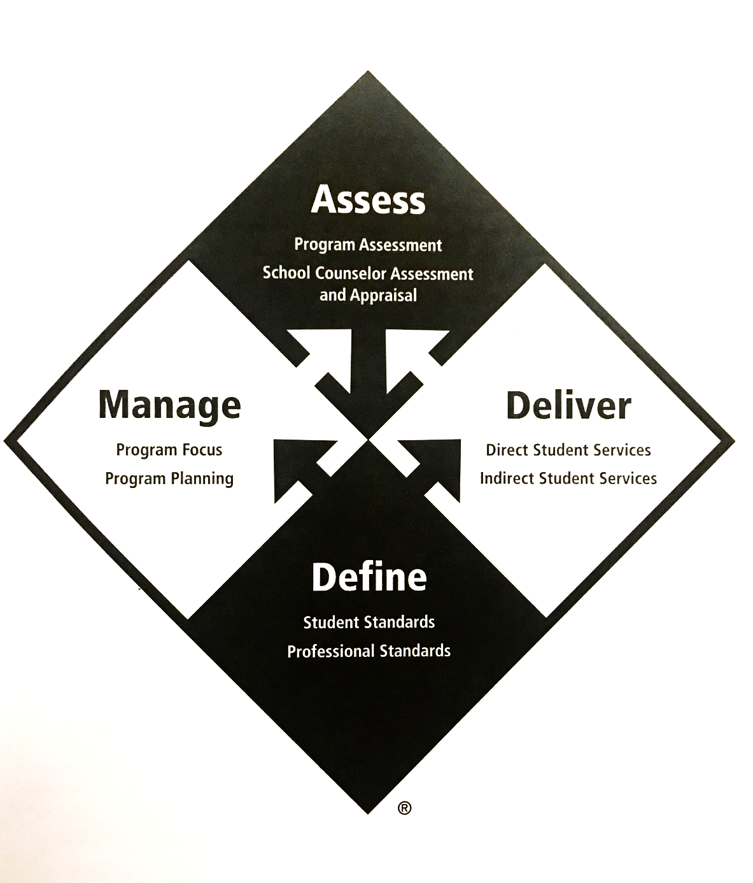

Define

Review the listed documents on the ASCA website: https://www.schoolcounselor.org/school-counselors/asca-national-model/templates-and-resources

STUDENT STANDARDS

PROFESSIONAL STANDARDS:
- Professional Standards & Competencies
- Ethical Standards

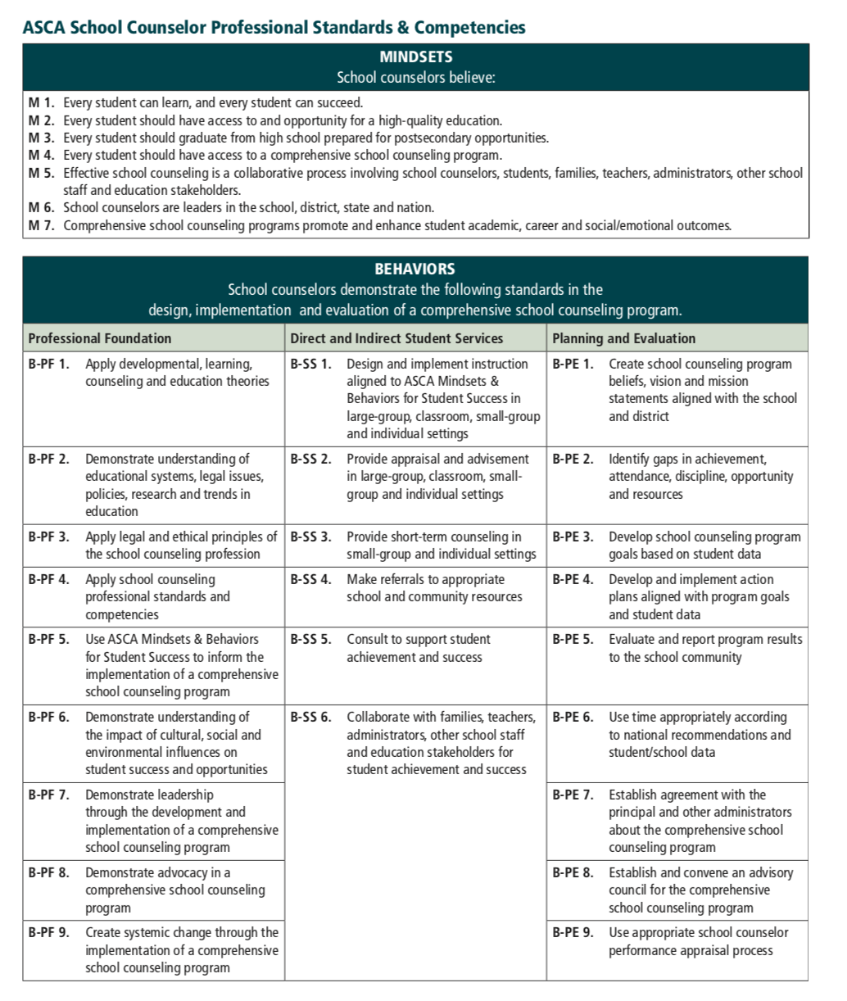

Manage

PROGRAM FOCUS

Beliefs

INSERT DEPARTMENT BELIEF STATEMENT
EXAMPLE: The school counselors of WCMS believe that school personnel should work to have every student achieve at their maximum and aid them with any additional support that is necessary. We also believe that the student body is made up of individual students with individual styles and personalities and presentations should be as diverse as the students.

Vision

INSERT DEPARTMENT VISION STATEMENT
EXAMPLE: The school counselors of WCMS believe that every student has a right to receive services according to individual need. Our counseling program is based on the Tennessee School Counseling and Guidance Standards and we actively recruit the participation of parents and other school personnel in an effort to meet the needs of the students.

Mission Statements

West Creek Middle School
INSERT SCHOOL MISSION STATEMENT
EXAMPLE: Our mission is to educate and inspire students to become life-long learners, independent thinkers, respectful individuals, and responsible citizens while providing a safe and engaging environment.

WCMS Counseling Center
INSERT DEPARTMENT MISSION STATEMENT
EXAMPLE: The mission of the WCMS Counseling Center is to provide all students with a counseling program to help meet their potential. We strive to provide educational programs and material to students, parents, and staff and to enhance communication between all three entities. We also engage in the development of students’ academic, career, and personal/social arenas in order to empower them to become successful in the school and when they depart.

PROGRAM PLANNING

Data
According to ASCA, “the school counselor program’s focus and direction are based on student needs as determined through a review of school data. Understanding and using data are essential to ensuring equitable services and that every student receives the benefits of the school counseling program.” During your fieldwork experience, be sure to:
- Connect with a staff member to review and examine school data
- Inquire about the school’s annual improvement goals
- Look for trends in data
- Compare the school’s data to district and state data

IF YOU COLLECT OTHER DATA, INCLUDE THAT INFORMATION HERE AS WELL. FOR EAXMPLE:
- Faculty Recommendations- student needs https://goo.gl/forms/wgOYw7hZI2ffMEWl2
- Faculty Needs assessment https://goo.gl/forms/DQiaw3ZMreMn7QA72
- Parent Needs Assessment https://goo.gl/forms/ix9gpCtYwNi2ZImF2
- Student Session survey https://goo.gl/forms/LefINMfuNBi9Kg243
- Student progress survey https://goo.gl/forms/h1azegRJBUvElg1k1
- Group pre assessment https://goo.gl/forms/UmhSkmfwju8DIpdC2

Annual Data Review
After you have reviewed the school data, identify gaps in achievement, attendance, and discipline for the various subgroups.

Annual Student Outcome Goals
Based on the data, the counseling center has identified the following goals for this year:

INSERT PROGRAM GOALS
EXAMPLE
- By May 2016, 8th grade boys with 10 or more discipline referrals/behavior notifications in the first marking period will decrease referrals/notifications by 25% in the last quarter.
- By May 2016, 8th grade students with two or more failing classes in the first marking period will decrease failures by one class in the last quarter.

Action Plans
IF YOU HAVE DEVELOPED SPECIFIC ACTION PLANS, INSERT THEM HERE. CLICK HERE FOR EXAMPLES: https://www.schoolcounselor.org/school-counselors/asca-national-model/templates-and-resources

Lesson Plans
IF YOU HAVE LESSON PLANS, INCLUDE A STATEMENT ON WHERE THE SUPERVISEE CAN LOCATE THEM FOR REVIEW (OR LIST HELPFUL WEBSITES WITH SAMPLE LESSON PLANS APPLICABLE TO YOUR SETTING)

Annual Administrative Conference
FORMERLY KNOWN AS THE MANAGEMENT AGREEMENT. INCLUDE A STATEMENT ON WHERE THE SUPERVISEE CAN LOCATE THIS FOR REVIEW.

Use of Time
PROVIDE A BRIEF OVERVIEW OF YOUR TIME TRACKING SYSTEM. INCLUDE A STATEMENT ON WHERE THE SUPERVISEE CAN LOCATE THIS FOR REVIEW.

Calendars

PROVIDE A DEPARTMENT CALENDER HERE. SEE EXAMPLE PROVIDED IN THE SPACE BELOW.

School Counseling Advisory Council
IF YOU HAVE AN ADVISORY COUNCIL, INCLUDE INFORMATION ABOUT THAT HERE.

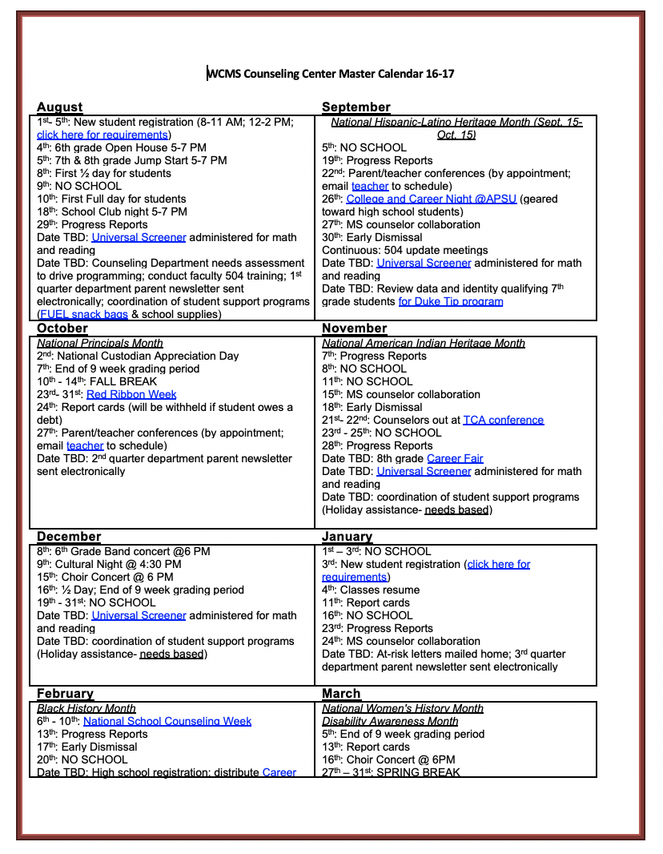

Deliver

Direct Student Services

Instruction
INCLUDE INFORMATION ON HOW YOUR DEPARTMENT PROVIDES INSTRUCTION TO STUDENTS. FOR EXAMPLE, DO YOU PRESENT CLASSROOM LESSONS OR ASSIST IN THE DEVELOPMENT/IMPLEMENTATION OF SCHOOL-WIDE CURRICULUM/ADVISORY LESSONS? WHAT DO THIS LOOK LIKE IN YOUR SCHOOL?

Appraisal & Advisement
THROUGH THIS PROCESS COUNSELORS HELP STUDENTS UNDERSTAND THEIR ABILITIES, VALUES, AND CAREER INTERESTS WHICH MAY RESULT IN COLLABORATIVE PLAN DEVELOPMENT. WHAT DOES THIS LOOK LIKE IN YOUR SCHOOL?

Counseling
HOW DO YOU OFFER THESE SERVICES IN YOUR SCHOOL? DO YOU HAVE GUIDELINES ON WHEN STUDENTS CAN BE PULLED AND FOR HOW LONG? DO YOU HAVE RESOURCES THAT YOU USE FOR SESSIONS?

Indirect Student Services

Consultation
HOW DO CONSULTEES (i.e. partnts/teachers) ACCESS THE SCHOOL COUNSELOR FOR CONSULTATION SERVICES? DO THE SCHOOL COUNSELORS SEEK CONSULTATION FROM ANY INDIVIDUALS/ORGANIZATIONS?

Collaboration
WHAT DOES THIS LOOK LIKE IN YOUR SCHOOL? WHAT COMMITTEES DO THE COUNSELORS PARTICIPATE IN? DOES YOUR DEPARTMENT OFFER WORKSHOPS OR ENGAGE IN ANY COMMUNITY PARTNERSHIPS (i.e. FUEL, PIE Partners)? DO YOU WORK WITH ANY OF THE FOLLOWING:
- CENTERSTONE
- MILITARY FAMILY LIFE CONSULTANT
- SOCIAL WORKERS

WHAT DOES CRISIS RESPONSE LOOK LIKE FOR COUNSELORS IN YOUR SCHOOL? WHAT CAN SUPERVISEES EXPECT IF THE FOLLOWING OCCURS?
- Imminent suicide attempt
- Drug overdose
- Aggressive reaction (present or imminent)
- Physical illness or adverse physical reactions requiring immediate medical attention
- Psychotic reaction or other serious psychological disturbance
- Report of child abuse
- Severe depression, anxiety, etc.

Referrals
INCLUDE GUIDELINES ON WHEN TO MAKE REFERRALS, TO WHOM, AND FOR WHAT REASONS (i.e. Mobile Crisis, DCS, mental health agencies, etc). IT MAY BE HELPFUL TO INCLUDE LINKS TO RELEVANT CMCSS POLICIES AS WELL: https://www.cmcss.net/administrative-policies/ (i.e. HUM-A009: Reporting Suspected Child Abuse).
BE SURE TO INCLUDE COMMUNITY RESOURCES THAT YOU FREQUENTLY USE (tutoring services, community assistance programs, etc.).

Assess

Program Assessment

School Counseling Program Assessment
DO YOU ASSESS YOUR PROGRAM ON AN ANNUAL BASIS? IF SO, INCLUDE INFORMATION ABOUT THAT HERE. BE ASURE TO DESCRIBE THE INSTRUMENTS USED, DISTRIBUTION METHODS, AND TIMELINE. CLICK HERE FOR AN EXAMPLE INSTRUMENT: https://goo.gl/forms/oeWiJ3uCPzW126WV2.

Annual Results Report
DO YOU COMPLETE AN ANNUAL REPORT AND DISSEMENTATTE TO STAKEHOLDERS? IF SO, INCLUDE A STATEMENT ON HOW SUPERVISEES CAN ACCESS THAT REPORT. THE ASCA WEBSITE PROVIDES SOME TEMPLATES, YOU CAN USE THE ONES PROVIDED OR CREATE YOUR OWN SUCH AS THIS ONE: https://drive.google.com/file/d/0B3Dq87i1rs8WVTlXWU1Janh0M0E/view?usp=sharing.

School Counselor Assessment & Appraisal
INCLUDE A STATEMENT ON HOW YOU ARE ASSESSED AS A COUNSELOR WITHIN YOUR SCHOOL. WHAT DOES YOUR EVALUATION PROCESS LOOK LIKE?

Supervisee Expectations

Professionalism

- We encourage membership in professional organizations such as ASCA, TCA, and TSCA. We attend annual conferences at the state as well as the national level.
- Please be sure to review the updated ASCA ethical standards and be prepared to abide by these standards at the field site level and beyond.
- Appearance:
  - Business casual- knee length dresses/skirts; no low-cut blouses; no spaghetti straps or shear tops
  - No gum
  - Display APSU badge at all times
  - Casual Fridays- no holes in jeans
- Cell phone use only during lunch period
- Activities at field site MUST be directly related to specific field site (i.e. no homework, applying for jobs, etc.)
- Arrive at 7 AM everyday- prepare for traffic
  - Check in and out with driver’s license everyday
- If an emergency arrives, notify supervisor as soon as possible
- If you know in advance that you will be out, please notify your supervisor as soon as possible
- Take initiative- look for ways you can contribute.
- Demonstrate respect to all employees.

Responsibilities
- Be sure to visit our school and department webpage to learn more about us.
- Complete time logs and collect supervisor signatures on a weekly basis.
- Be prepared to engage in some indirect hours of essential administrative duties.
- Be ready to be a team player and make positive contributions to your environment.
- Share your goals with your supervisor.

